RESUME  ARUN P SAJU  PULAVELIL HOUSE  PERIYAPPURAM P O  ERNAKULAM DISTRICT  686667  E-mail:  arunpsaju1993@gmail.com  Mobile: 9645373550  Personal information  Father’s name  Mr. P C SAJU  Mother’s Name  Mrs. LEELAMMA SAJU  Date of birth  20-04-1993  Sex  Male  Nationality  Indian  Marital Status:  - Single  Linguistic Abilities:  - English  - Malayalam  - Hindi  Driving License :  M/C with Gr & LMV | CAREER OBJECTIVE  To work in a reputed organization where I can apply my knowledge and skills with hard work and do my duties sincerely.  EDUCATIONAL QUALIFICATION  - Currently Pursuing MBA at Berchmans Institute of Management Studies.  POST GRADUATION  MBA : Pursuing  University : Mahatma Gandhi University  College : Berchmans Institute of Management Studies  Year : 2013-2015  Marks scored : 66% (First semester)  GRADUATION  COURSE : B.Com  University : Mahatma Gandhi University  College : Mar Augesthinose college Ramapuram  Year : 2010-2013  Marks scored : 82%  HIGHER SECONDARY  +2 : Commerce  Board : State Board  School : St.Peter’s HSS Elanji  Year : 2010  Marks scored : 78%  SECONDARY  10th : State Board  School : MKM HSS Piravom  Year : 2008  Marks scored : 72%  EXPERIENCES & ACHIEVEMENTS  - Industrial visit to Synthite at 2014  - Industrial visit to “KELTRON” at Trivandrum 2012  - Hands on experience in Tally ERP 9, MS Word, MS Power point.  - Served as a member of the Organizational Committee for EGEIRO 2013, the National Management Fest conducted by Berchmans Institute of Management Studies.  - Served as coordinator of marketing games for PASIO 2014 National Management Fest conducted by Berchmans Institute of Management Studies.  - Attended various National Management fests.  TRAINING UNDERGONE  - Two days training about “Neuro Linguistics Programme” organized by BERCHMANS INSTITUTE OF MANAGEMENT STUDIES  - Two days training about “ Effective use of body Language”taken by  Prof. Venkatesh organized by Mar.Augesthinose college Ramapuram.  PROJECT WORK IN B.Com  “Brand Preference And Customer Satisfaction Towards Laptops With Special Reference To Elanji Village” 2013  ACADEMIC PROJECT EXPOSURE  - Projects Undertaken:  - Internship at Big Bazaar on Retailing, in the month of September 2013 at Big Bazaar Trivandrum.  - A project on Marketing, Diabetic Campaign for Dhathri Ayurvedics Pvt Ltd. in the month of May 2013.  - Internship at CHASS, Changanacherry, on Micro Finance in the month of December 2013.  - Organizational study at ‘ Meat Products of India LTD Edayar ’ 2014  - Seminars and Conference Attended:  - Attended the Berchmans National Conference 2014  REFERENCE  1.Mr.Jithin k Thomas  Prof. Berchmans Institute Of Management Studies  Phone No: 91-9497216007  DECLARATION  I hereby declare that the above written particulars are true and correct to the best of my knowledge and belief.  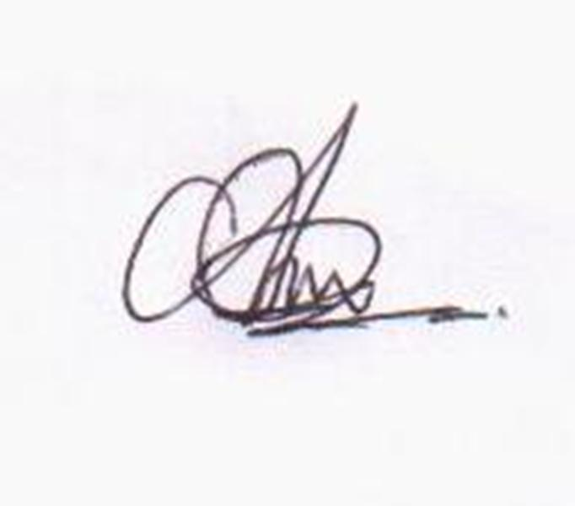  Place: Piravom ARUN P SAJU  Date: 27-02-2015

